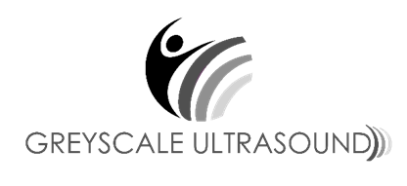
PRICE LIST AS AT NOVEMBER 2024
Greyscale Ultrasound offers a fully comprehensive ultrasound service. All prices include GST.
Please note, not all available ultrasound’s are outlined below. Please contact admin@greyscaleultrasound.co.nz for questions around specific or more focused tests.
ACC Ultrasounds Free (excluding ultrasound guided steroid / cortisone injections)
We are a Southern Cross affilated provider. Pre-approval required, there may be a small out of pocket cost for the patient depending on their cover type.
ULTRASOUND TEST | PRICE  (INCL GST)
ACC Free (excluding ultrasound guided steroid / cortisone injections)
ACC injections – pre-approval required | $100
Private injections | $370
DEXA
Bone Mineral Density or Body Mass Composition | $215
General
Abdominal (Liver, Gall Bladder, Pancreas etc) | $250
Renal | $260
Pelvic Gynaecological, Prostate | $260
Abdomen and Pelvis | $320
Small Parts
Breast Bilateral | $230
Thyroid / Neck | $230
Musculoskeletal General | $230
Obstetric Surcharge
Pregnancy scans (Dating, Nuchal & third trimester) | $60
Morphology / Anatomy (20-22 week scan) | $80
Additional cost for twins after dating scan
Vacsular
DVT unilateral | $260
DVT bilateral | $400
Carotid | $420

Please enquire if you have any questions or if your test is not outlined above. Special circumstances will be considered.

